Revit Server IIS Requirements for Server 2016

- Launch the Add roles and features option from the Server Manager Dashboard.

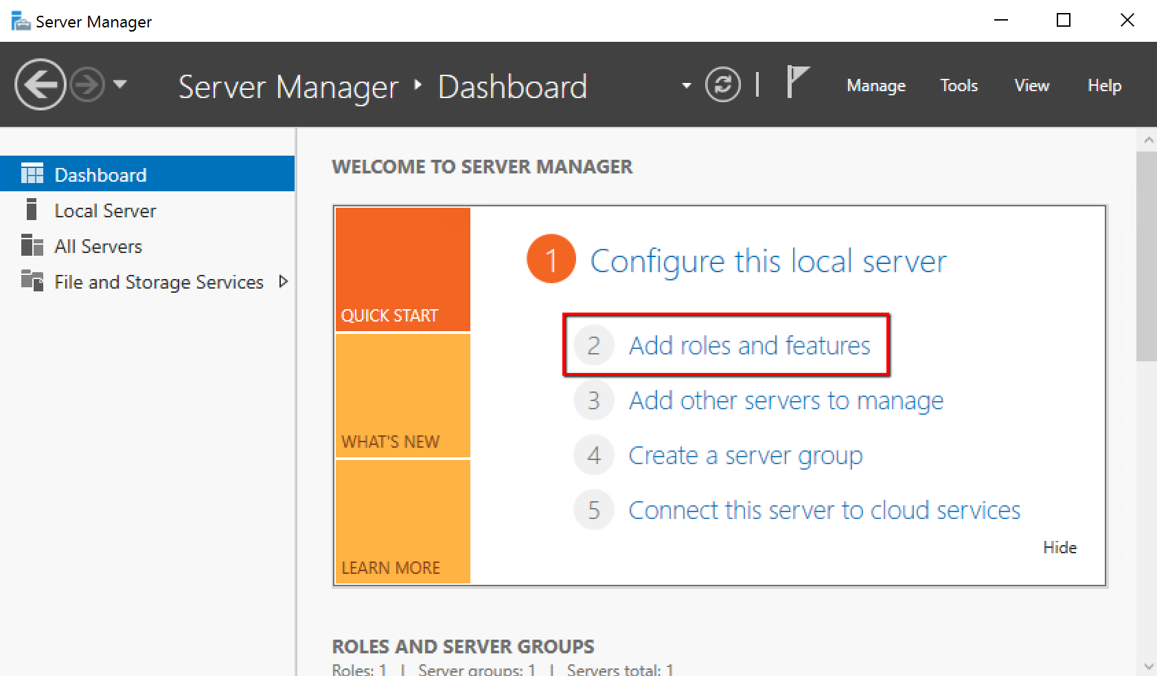

- Select Role-based or feature-based installation.

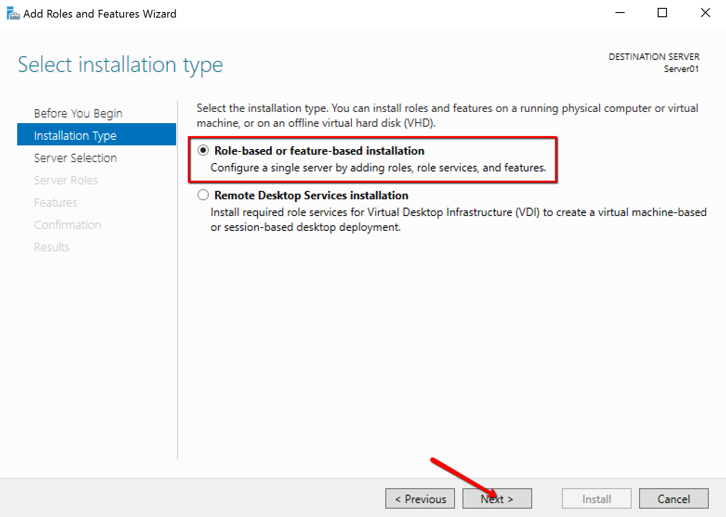
- Select Server to continue.

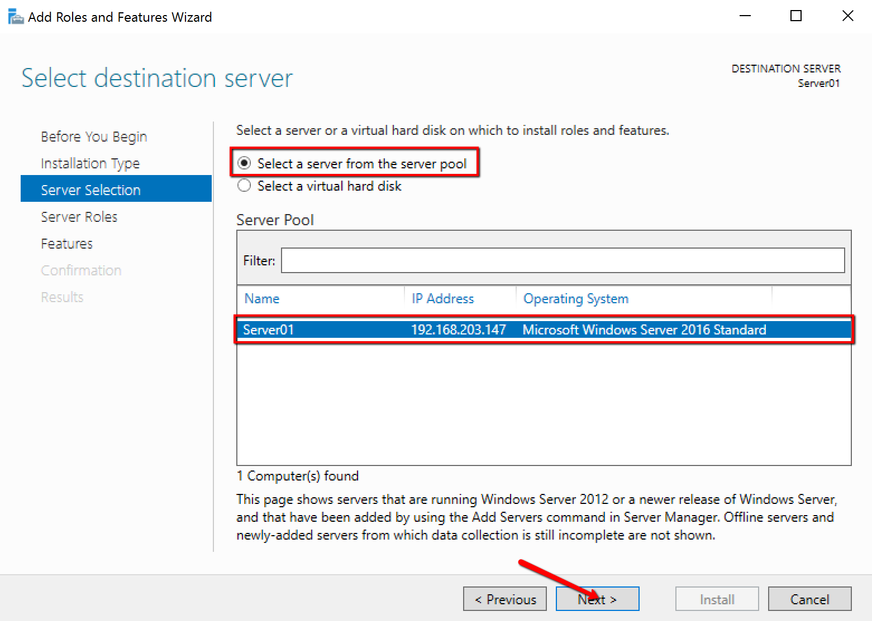

- Select Web Server (IIS) and add any features that are automatically required if prompted.

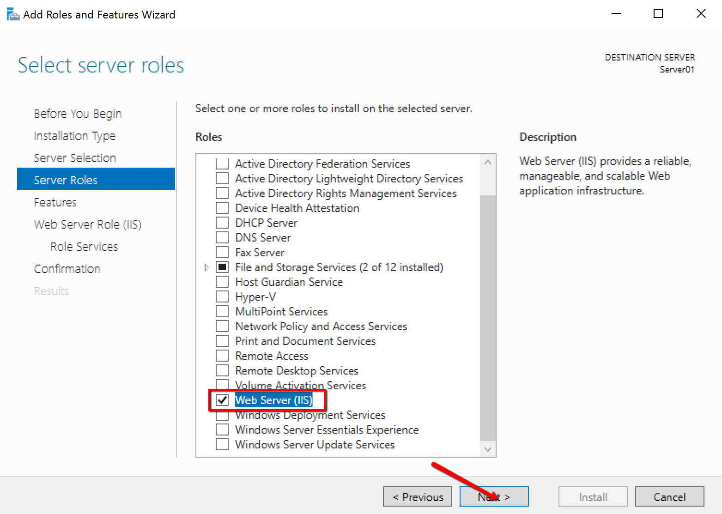
- Install the features, HTTP Activation, TCP Activation and TCP Port Sharing by:
  - Expanding the .NET Framework 4.6 Features >> WCF Services

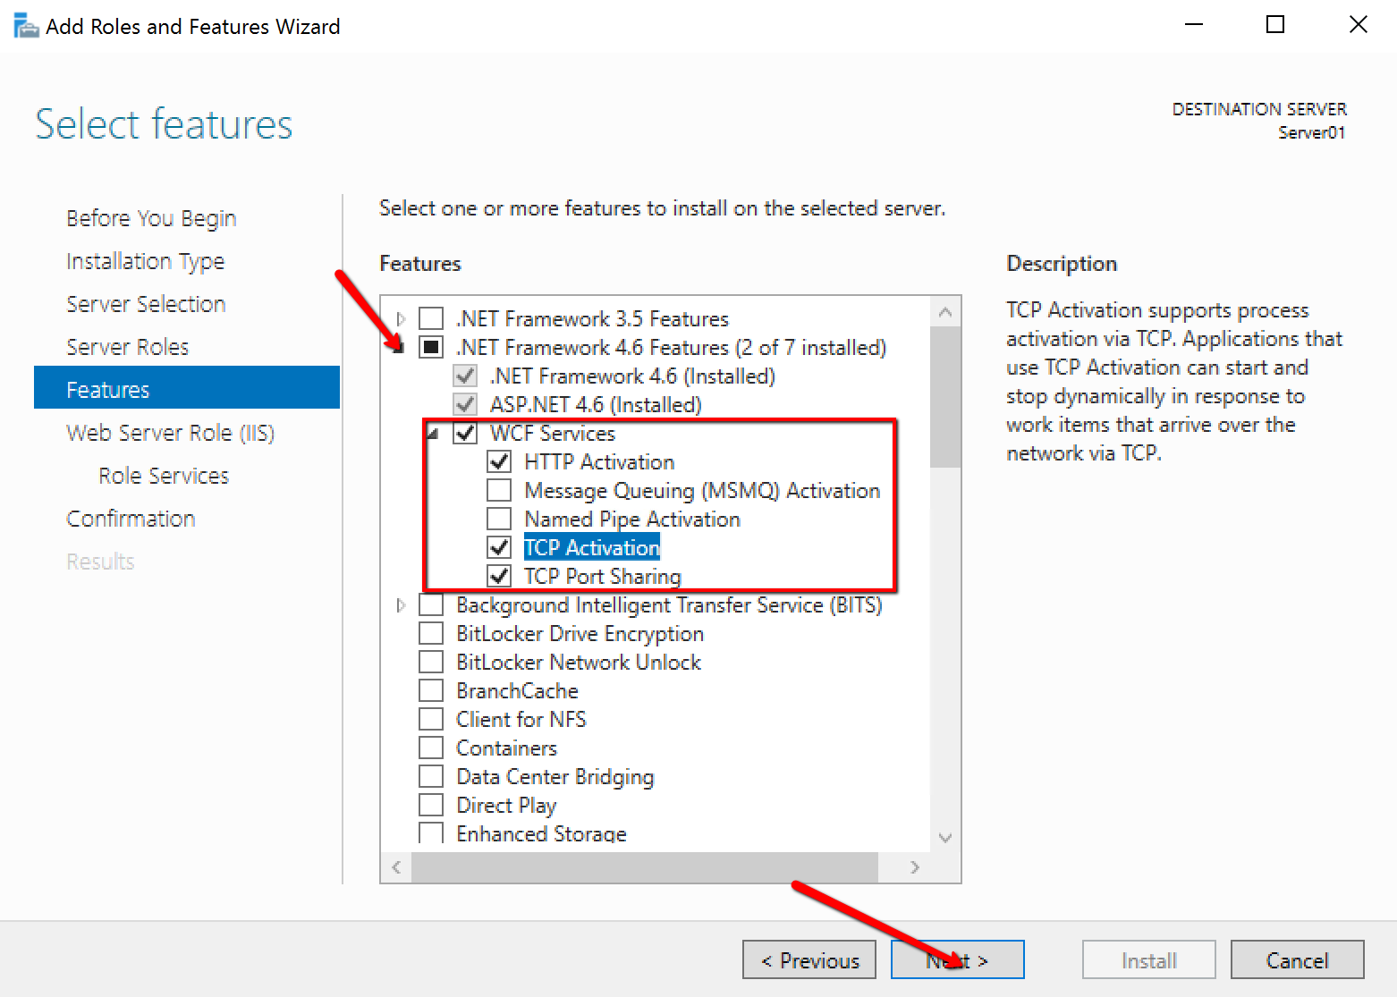

- From the Role Services, install, ASP, CGI and Server Side Includes by:
  - Expanding Application Development

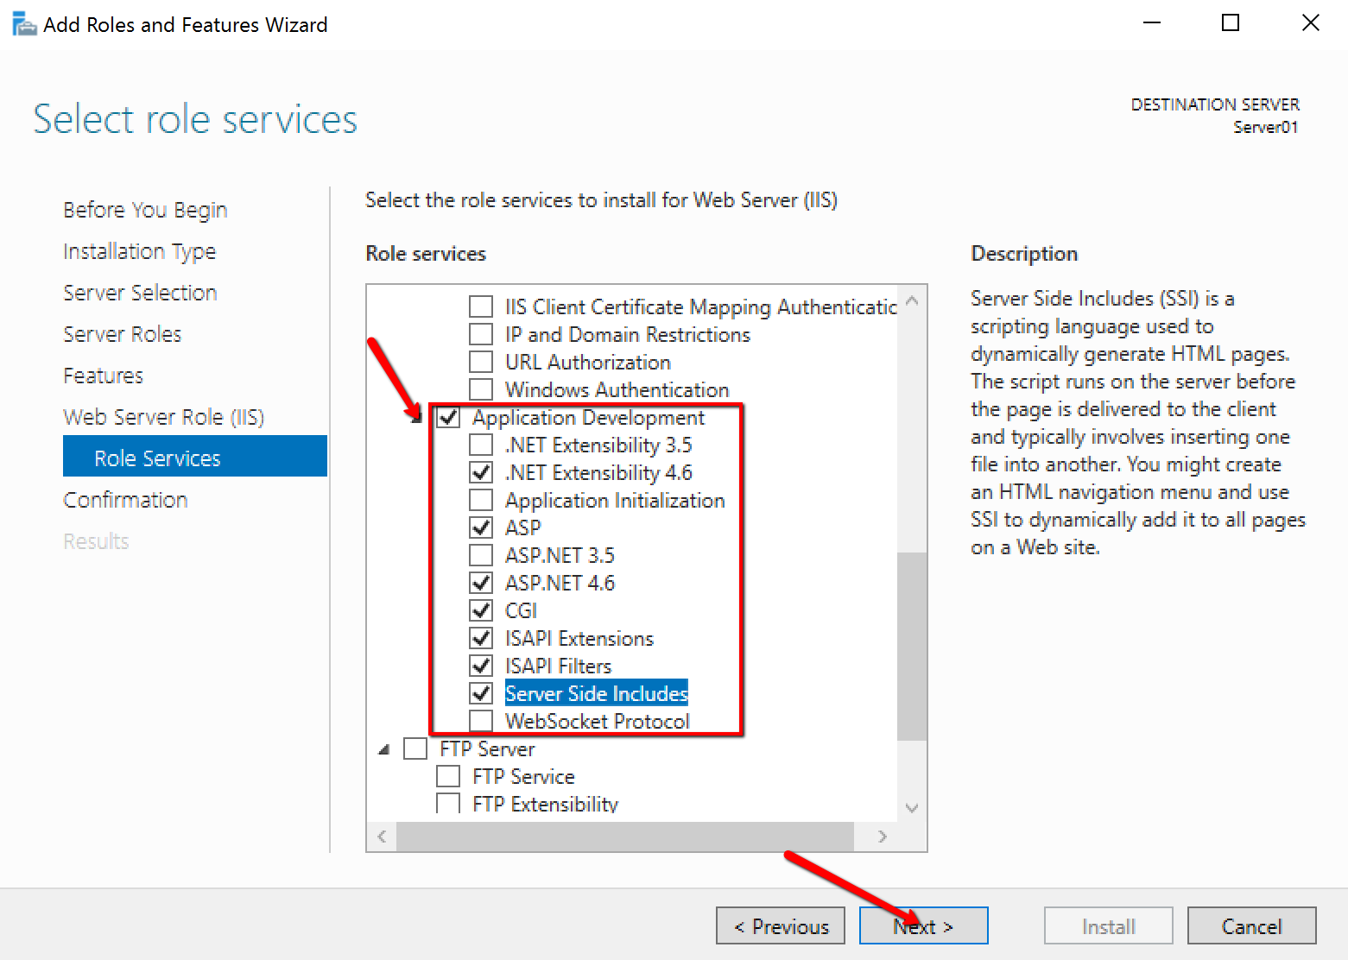

- Again from the Role Services, install, IIS 6 Metabase Compatibility and IIS 6 Scripting Tools by:
  - Expanding Management Tools >> IIS 6 Management Compatibility

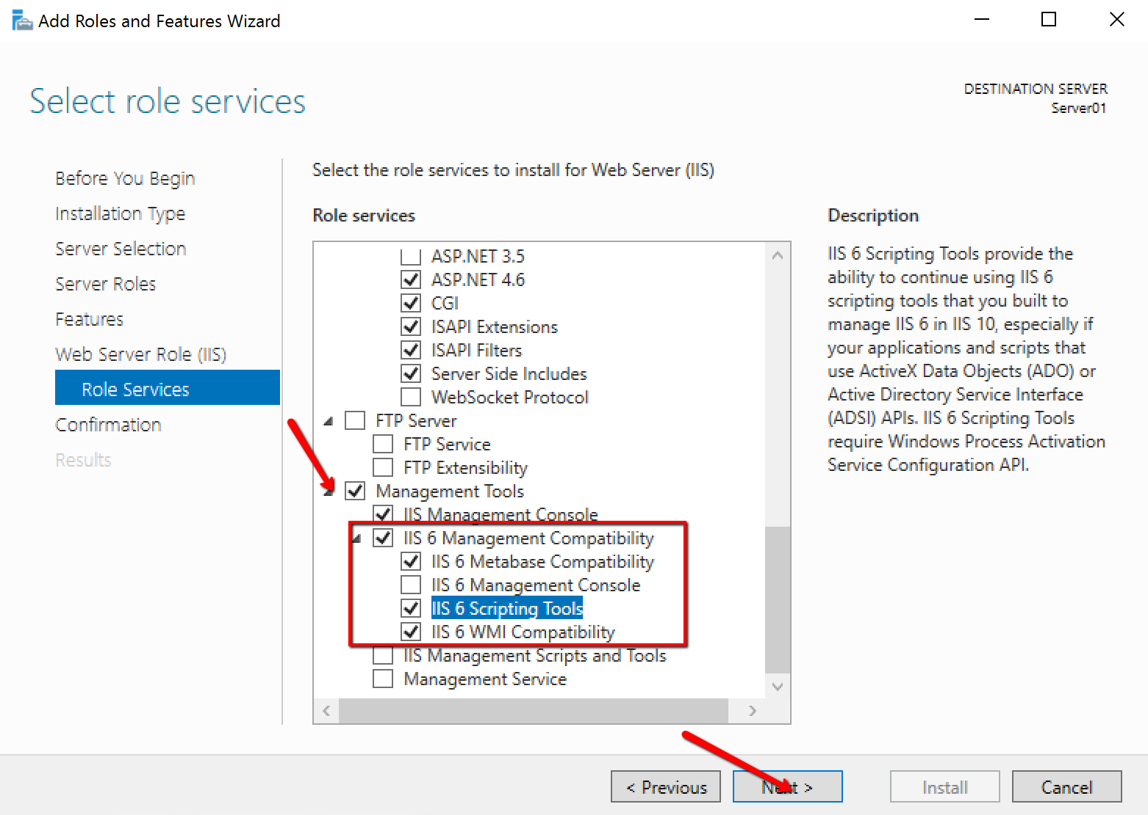

- Confirm installation and select Install.

